**Management Plan: Sprint #3**

**Gnatt Chart:** 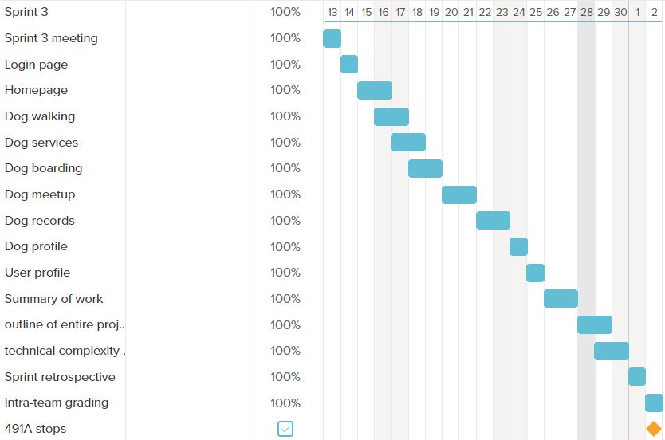

In this sprint, the primary goal was to continue coding the features pages and fix some bugs that we found in our code from our previous sprint and also to complete other documents that are to be submitted this sprint.

**Code Development velocity calculation:**

In this sprint, we had planned to finish 94 points worth tasks and we were able to finish it on time.

**Sprint Retrospective:**We finished all the tasks that were planned for this sprint on time. 94 points were planned in this sprint. We were able to complete those 94 points on time. Commitment per person every week= 5hrs.Team commitment per sprint= 5hrs *6 people * 3 weeks = 90hrs. The burndown chart was not exactly linear because of the learning curve. The right amount of tasks were assigned in this sprint which could be completed in the given timeframe. We need to provide more time for testing the code that we wrote. We need to make the web application more functional.

For the next sprint, we will provide more functionality to the web application making the application more responsive. We also need to make the web application more attractive by adding the UI elements.